Investigating sounds

Aim

To investigate a number of different ways in which sounds are produced.
Equipment

Activity A
_ tuning forks of different frequencies
_ large rubber bung
_ ping-pong ball hanging on a thread
_ clamp stand

Activity B
_ board with six nails and elastic bands stretched between them

What to do
Carry out the experiments below, and for each one answer these three questions.
1 What is producing the sound?
2 How can the sound be made louder or softer?
3 How can the sound be made higher pitched or lower pitched?

A The tuning fork

Hold the tuning fork by the stem and hit one prong firmly against the rubber bung. Look closely at the fork. What is happening while it is making the sound?
Sound the tuning fork again and touch one prong against the hanging ping-pong ball. What happens to the ball?
Hit the rubber bung softly with the fork, so it just makes a sound, and then touch the ping-pong ball again. Is there any difference between hitting the tuning fork firmly and softly?
Sound a different sized tuning fork. Is the note higher or lower than with the first tuning fork?

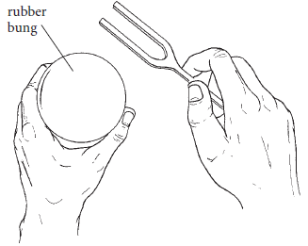

B The rubber band
Wearing goggles, pluck one of the rubber bands sideways and look closely at the band while it is making the sound. What does it do?
Pluck the other rubber bands. What difference do you notice in the sound? Can you see a pattern? (The longer the band, the . . . )
Try plucking the same rubber band softly and then firmly. Is there a difference in the sound?

What to do
Carry out the experiments below, and for each one answer these three questions.
1 What is producing the sound?
2 How can the sound be made louder or softer?
3 How can the sound be made higher pitched or lower pitched?

C The ruler

Hold the ruler down on the bench so that your hand is about 3 cm in from the
edge of the bench and about 20 cm of ruler extends over the edge of the bench.
Push the end of the ruler down slightly and let go. Does the ruler make a sound?
How does it move to make the sound?
Try again, but push the ruler down a bit more this time. Does the sound get louder or softer?
Try again, but move the ruler so the amount hanging over the end of the bench is shorter. Does the sound get higher or lower?
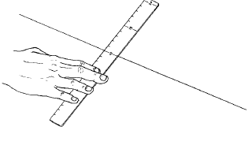

D Drinking straw pipes

Flatten about 2 cm of the end of a drinking straw. Cut the tapered end so that it makes a point, like this:
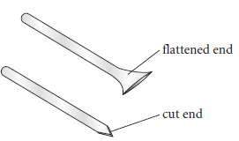
Put this cut end into your mouth and blow.

Does it make a sound? What do you feel?
Practise with the straw until you can remember the sound. Can you change the loudness?
Cut off 2 cm of the rounded end of the straw to make it shorter. Blow into the pointed end again. Has the sound changed? Is it higher or lower?

